Caesar cipher (java) Project pictures

Total images: 06

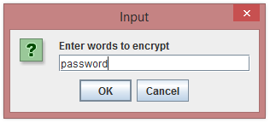

Fig 1: First pop-up to enter the plain text for encryption

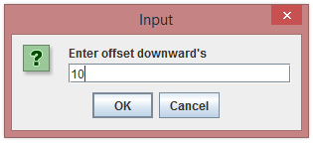

Fig 2: Second pop-up to enter the shift downwards

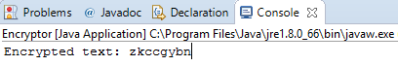

Fig 3: Encrypted text in the console

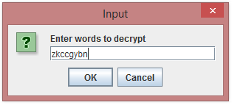

Fig 4: Third pop-up to enter the cipher text for decryption (entered the encrypted text to cross-check)

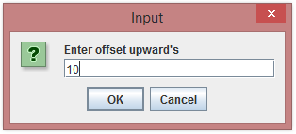

Fig 5: Fourth pop-up to enter the shift upwards (entered same number of shifts)

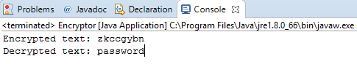

Fig 6: Final encrypted text and decrypted text in the console